Intern Exercise no. BC02 ver. 1.0

Auto-Assign Customer Discount Group - Concept

Date: 08.08.2022

Author: Mateusz Wysocki

Spis treści

1. Story 3

2. Solution Requirements 3

3. Concept of modification 4

3.1. New page and field for set requirements 4

3.2. New group in Sales & Receivables Setup 5

3.3. New fields in Customer Card 6

3.4. New actions in Customer Card and Customers pages. 7

3.5. New page and table to store history 8

4. Scenario Testing 9

# Story

Sales Company with high volume of customers (grouped into 10 segments) needs to simplify the process of managing the sales discounts. Currently salespersons are responsibly to assign proper discount based on the customer turnover from the last 3 months. Unfortunately that is time-consuming and error prone process. Therefore Sales Company would like to improve that process by making it fully automated under Business Central platform they currently use.

# Solution Requirements

* It should be possible to define a list of the pairs: turnover level and applicable discount group. It should not be possible to delete customer discount group if used in such setup.
* Additionally It should be also possible to define the time period for which turnover should be taken into account when auto-applying proper customer discount group.
* Solution needs to be enabled to affects Business Central standard logic. By default, after installation, functionality should be disabled.
* User should be able to run feature auto-assign customer discount group for the specific customer.
* Alternatively should be possible to run auto-assign as a report for the filtered customers (or schedule as a background task).
* Auto-assigned customer discount group is valid only within defined period.
* User should be able to access all previously auto-assigned customer discounts groups for the specific customer.
* Information about who and when run last auto-assign discount group check should be easily access from the customer card.
* Auto-assign should be skipped for the customer with valid auto-assign customer discount group.
* Solution should auto-assign customer discount group for the newly created customers.
* It should not be possible to issue a sales document for the customer with not valid auto-assign customer discount group.
* It should not be possible to manually manipulate with customer discount group.

# Concept of modification

## New page and field for set requirements

I am going to make new table and page “Requirements Auto Ass. Disc. Group”. That page will be used to assign to “Customer Disc. Groups” by value in turnover period Sales (LCY).

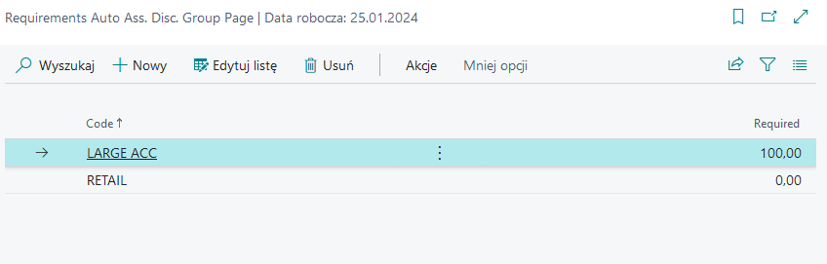

## New group in Sales & Receivables Setup

User in Sales & Receivables Setup can turn on and turn off Auto assigned option.

When User turn off option Communicat will be showed.

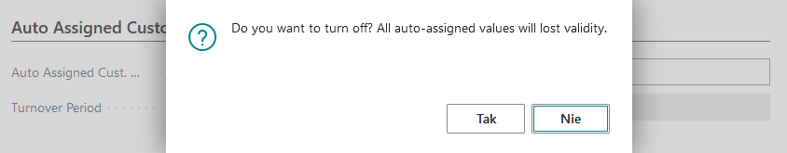

## New fields in Customer Card

Customer Card Page and Customer Table will have new fields.

Turn off

Turn on

## New actions in Customer Card and Customers pages.

New action in Customer Card page will be added. That action will be used to atomatic assign Customer to discount group.

New action with request page will be added to Requirements list page. It will be used to assign all Customers. Customers with valid auto-assign customer discount group will be skipped.

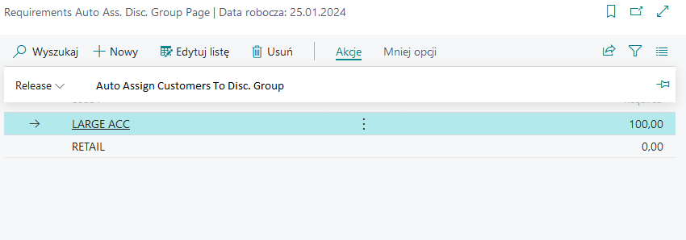

## New page and table to store history

New page and table will store history about all assigned to group. When user open Assign to Customer Discount group page from Customer card that page will have filter for one Customer.

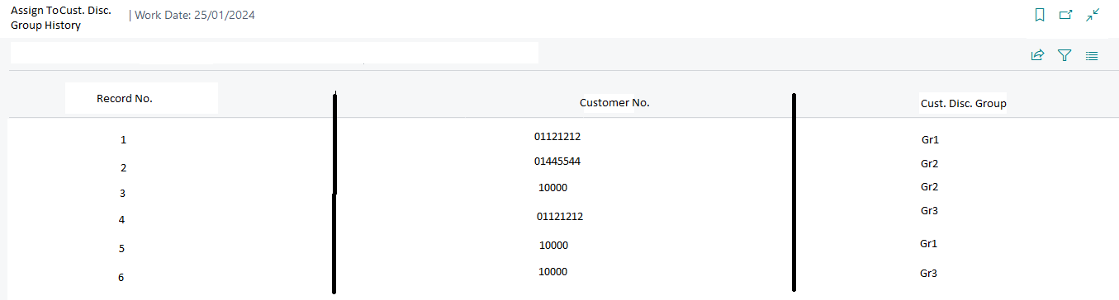

# Scenario Testing

Given:

Value of Auto Assigned Cust. Disc. Group is true.

When:

Value of Auto Assigned Cust. Disc. is changed for false.  
Option "No" is selected from Confirm window.

Then:

Value of Auto Assigned Cust. Disc. Group is true.

Given:

Value of Auto Assigned Cust. Disc. Group is true.

When:

Value of Auto Assigned Cust. Disc. is changed for false.  
Option "Yes" is selected from Confirm window.

Then:

Value of Auto Assigned Cust. Disc. Group is false.

Given:

In IMW Req. Auto. Cust. Disc. Gr. table only one record has value 0 in required field.  
Status is "Open".

When:

"Release" action is started in Requirements Auto Ass. Disc. Group page.

Then:

Status is changed for "Released".

Given:

In IMW Req. Auto. Cust. Disc. Gr. table all records have different value then 0 in required field.  
Status is "Open".

When:

"Release" action is started in Requirements Auto Ass. Disc. Group page.

Then:

Status is not changed for "Released". Status still is "Open".

Given:

Customer has no discount group.  
Value of Auto Assigned Cust. Disc. Group is true.  
Status is "Released".

When:

"Auto Assign To Disc. Group" action is started in Customer Card page.

Then:

Customer is allocated to discount group.

New record is added to "Assign To Cust. Disc. Group History".

Given:

Value of Auto Assigned Cust. Disc. Group is true.  
Status is "Released".

When:

"Auto Assign Customers To Disc. Group" action is started in Auto Ass. Disc. Group page.

Then:

All Customers are in discount group.

New records are added to "Assign To Cust. Disc. Group History".

Given:

Value of Auto Assigned Cust. Disc. Group is true.  
Status is "Released".

When:

"Auto Assign Customers To Disc. Group" action is started in Auto Ass. Disc. Group page.

Option "Yes" is selected from Confirm window.

Then:

Action is runned for all customers.

All Customers are in discount group.

New records are added to "Assign To Cust. Disc. Group History".

Given:

Customer has no discount group.  
Value of Auto Assigned Cust. Disc. Group is true.

When:

Customer is added to Sales Order.

Then:

Error

Customer can't be added.

Given:

Customer has no discount group.  
Value of Auto Assigned Cust. Disc. Group is true.

Auto Assgined Disc. Expiration Date is expired.

When:

Customer is added to Sales Order.

Then:

Error

Customer can't be added.

Given:

Value of Auto Assigned Cust. Disc. Group is true.  
Status is "Released".

When:

New Customer is created.

Then:

Customer is created.  
Customer is allocated to discount group.

Given:

Value of Auto Assigned Cust. Disc. Group is true.  
Status is "Open".

When:

New Customer is created.

Then:

Customer is created.  
Customer is not allocated to discount group.

Given:

Value of Auto Assigned Cust. Disc. Group is true.

When:

Manually allocat customer to discount group.

Then:

Customer allocation can't be changed.

Given:

One discount group has not requirement.

When:

In Requirements Auto Ass. Disc. Group page new record is created.   
Code is salected.  
Required is salected different than other.

Then:

New record is created.

The calculation below assumes that the task will be performer on the client’s test environment. The calculation also includes testing, documentation and client acceptance.

Total cost of implementation: 80 man-hours.